Task 1
#include <stdio.h>

int main() {
int matrix[3][3];
int i, j;
int isSymmetric = 1;

printf("Enter the elements of the 3x3 matrix row-wise:\n");
for (i = 0; i < 3; i++) {
for (j = 0; j < 3; j++) {
printf("Enter element at position [%d][%d]: ", i, j);
scanf("%d", &matrix[i][j]);
}
}

printf("\nThe entered matrix is:\n");
for (i = 0; i < 3; i++) {
for (j = 0; j < 3; j++) {
printf("%d ", matrix[i][j]);
}
printf("\n");
}

for (i = 0; i < 3; i++) {
for (j = 0; j < 3; j++) {
if (matrix[i][j] != matrix[j][i]) {
isSymmetric = 0;
break;
}
}
if (isSymmetric == 0)
break;
}

if (isSymmetric == 1)
printf("\nThe matrix is Symmetric.\n");
else
printf("\nThe matrix is Not Symmetric.\n");

return 0;
}

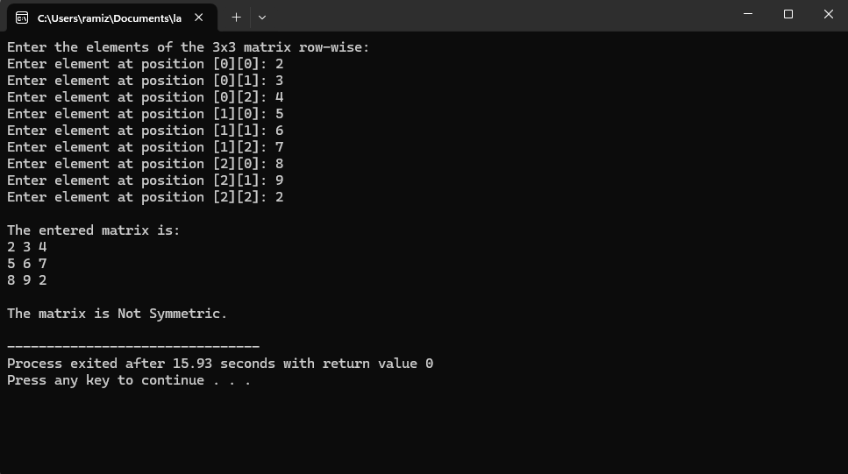

Task2
#include <stdio.h>

int main() {
int n, i, j, space;

printf("Enter the number of rows: ");
scanf("%d", &n);

for (i = 1; i <= n; i++) {

for (space = n - i; space > 0; space--) {
printf(" ");
}

for (j = 1; j <= i; j++) {
printf("%d ", j);
}

printf("\n");
}

return 0;
}
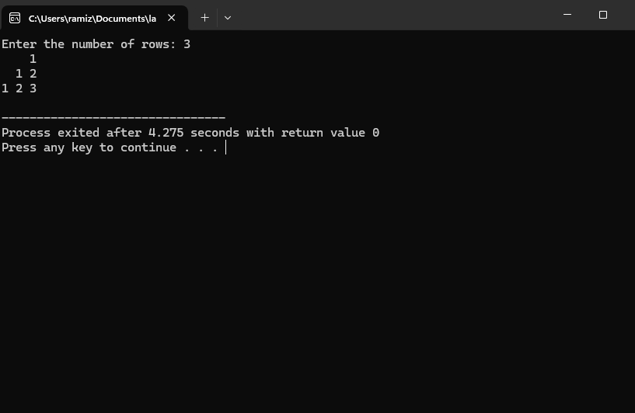

TASK 3
#include <stdio.h>

int main() {
int n, i, j;
int matrix[10][10];
int mainSum = 0, secondarySum = 0, totalSum = 0;

printf("Enter the size of the square matrix (n): ");
scanf("%d", &n);

printf("Enter the elements of the %dx%d matrix:\n", n, n);
for (i = 0; i < n; i++) {
for (j = 0; j < n; j++) {
scanf("%d", &matrix[i][j]);
}
}

for (i = 0; i < n; i++) {
for (j = 0; j < n; j++) {
if (i == j)
mainSum += matrix[i][j];
if (i + j == n - 1)
secondarySum += matrix[i][j];
}
}

totalSum = mainSum + secondarySum;

if (n % 2 != 0) {
totalSum -= matrix[n / 2][n / 2];
}

printf("\nSum of main diagonal = %d", mainSum);
printf("\nSum of secondary diagonal = %d", secondarySum);
printf("\nTotal sum of both diagonals = %d\n", totalSum);

return 0;
}

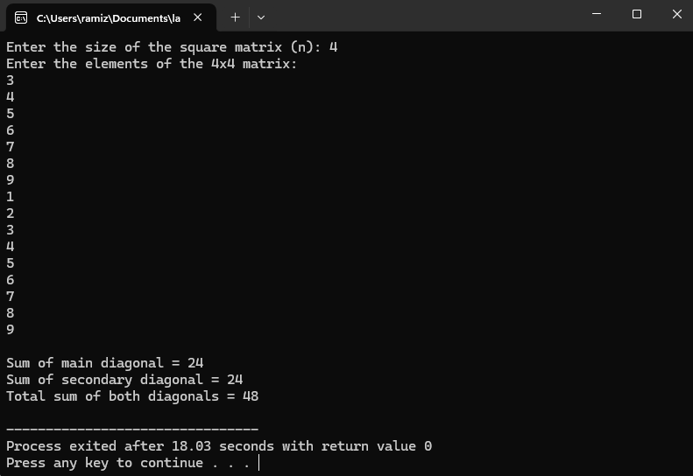
Task4
#include <stdio.h>

int main() {
int matrix[3][3];
int i, j;
int isUpper = 1, isLower = 1;

printf("Enter the elements of the 3x3 matrix:\n");
for (i = 0; i < 3; i++) {
for (j = 0; j < 3; j++) {
scanf("%d", &matrix[i][j]);
}
}

printf("\nThe entered matrix is:\n");
for (i = 0; i < 3; i++) {
for (j = 0; j < 3; j++) {
printf("%d ", matrix[i][j]);
}
printf("\n");
}

for (i = 0; i < 3; i++) {
for (j = 0; j < 3; j++) {
if (i > j && matrix[i][j] != 0)
isUpper = 0;
if (i < j && matrix[i][j] != 0)
isLower = 0;
}
}

if (isUpper == 1 && isLower == 0)
printf("\nThe matrix is an Upper Triangular Matrix.\n");
else if (isLower == 1 && isUpper == 0)
printf("\nThe matrix is a Lower Triangular Matrix.\n");
else if (isUpper == 1 && isLower == 1)
printf("\nThe matrix is both Upper and Lower Triangular (Diagonal Matrix).\n");
else
printf("\nThe matrix is Neither Upper nor Lower Triangular.\n");

return 0;
}
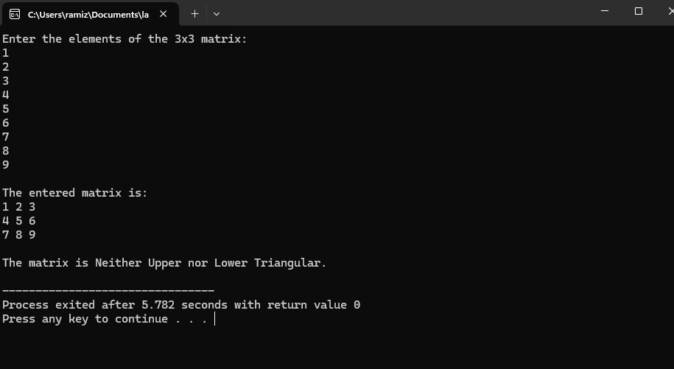
Task5
#include <stdio.h>

int main() {
int n, i, j, space;
printf("Enter number of rows for the top half: ");
scanf("%d", &n);

for (i = 1; i <= n; i++) {
for (space = n - i; space > 0; space--)
printf(" ");
for (j = 1; j <= 2 * i - 1; j++)
printf("*");
printf("\n");
}

for (i = n - 1; i >= 1; i--) {
for (space = n - i; space > 0; space--)
printf(" ");
for (j = 1; j <= 2 * i - 1; j++)
printf("*");
printf("\n");
}

return 0;
}
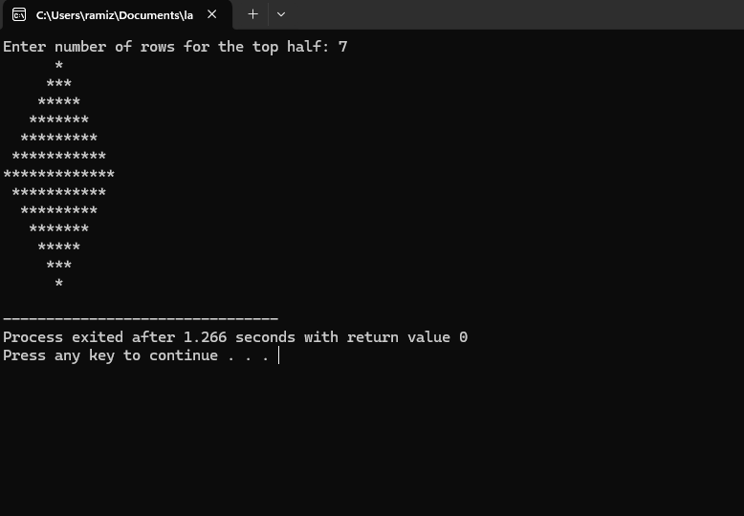
Task 6
#include <stdio.h>

int main() {
int matrix[3][3], transpose[3][3];
int i, j;

printf("Enter elements of 3x3 matrix:\n");
for (i = 0; i < 3; i++) {
for (j = 0; j < 3; j++) {
scanf("%d", &matrix[i][j]);
}
}

for (i = 0; i < 3; i++) {
for (j = 0; j < 3; j++) {
transpose[j][i] = matrix[i][j];
}
}

printf("\nOriginal matrix:\n");
for (i = 0; i < 3; i++) {
for (j = 0; j < 3; j++) {
printf("%d ", matrix[i][j]);
}
printf("\n");
}

printf("\nTransposed matrix:\n");
for (i = 0; i < 3; i++) {
for (j = 0; j < 3; j++) {
printf("%d ", transpose[i][j]);
}
printf("\n");
}

return 0;
}
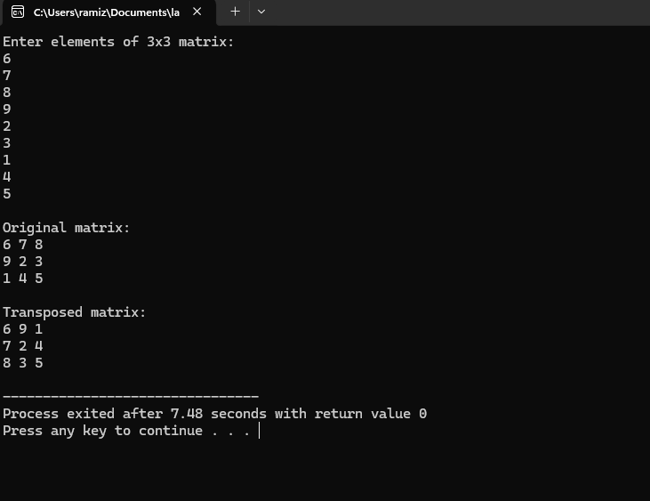

Task 7
#include <stdio.h>

int main() {
int n, i, j, k;
int a[3][3], b[3][3], product[3][3];

printf("Enter size of square matrices (2 or 3): ");
scanf("%d", &n);

printf("Enter elements of first matrix:\n");
for (i = 0; i < n; i++)
for (j = 0; j < n; j++)
scanf("%d", &a[i][j]);

printf("Enter elements of second matrix:\n");
for (i = 0; i < n; i++)
for (j = 0; j < n; j++)
scanf("%d", &b[i][j]);

for (i = 0; i < n; i++)
for (j = 0; j < n; j++) {
product[i][j] = 0;
for (k = 0; k < n; k++)
product[i][j] += a[i][k] * b[k][j];
}

printf("\nProduct matrix:\n");
for (i = 0; i < n; i++) {
for (j = 0; j < n; j++)
printf("%d ", product[i][j]);
printf("\n");
}

return 0;
}

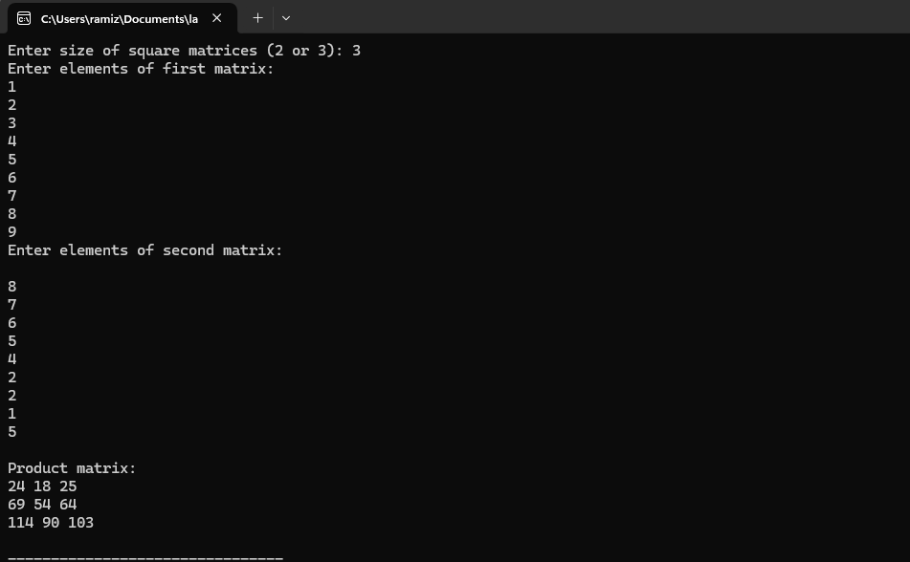

Task 8
#include <stdio.h>

int main() {
int matrix[3][3];
int i, j;
int even = 0, odd = 0, positive = 0, negative = 0, zero = 0;

printf("Enter elements of 3x3 matrix:\n");
for (i = 0; i < 3; i++) {
for (j = 0; j < 3; j++) {
scanf("%d", &matrix[i][j]);
}
}

for (i = 0; i < 3; i++) {
for (j = 0; j < 3; j++) {
if (matrix[i][j] % 2 == 0)
even++;
else
odd++;

if (matrix[i][j] > 0)
positive++;
else if (matrix[i][j] < 0)
negative++;
else
zero++;
}
}

printf("\nNumber of even elements: %d", even);
printf("\nNumber of odd elements: %d", odd);
printf("\nNumber of positive elements: %d", positive);
printf("\nNumber of negative elements: %d", negative);
printf("\nNumber of zero elements: %d\n", zero);

return 0;
}
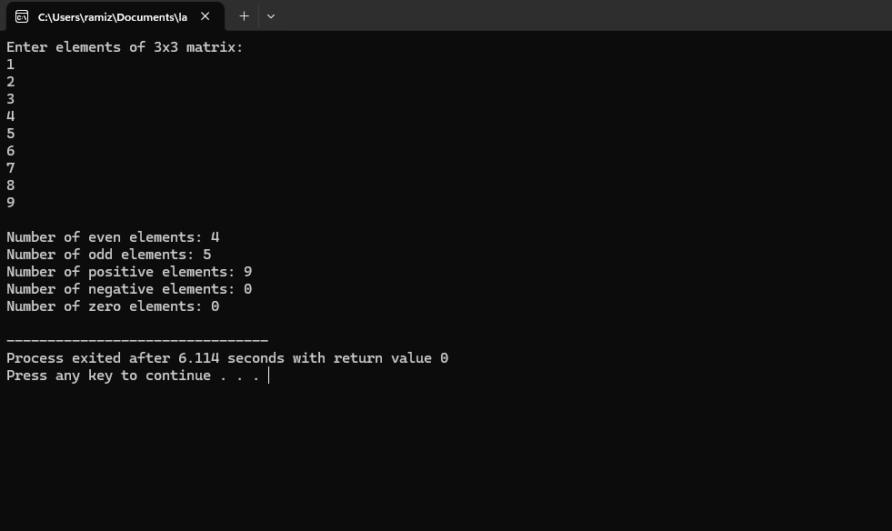
Task 9

#include <stdio.h>

int main() {
int matrix[3][3], rotated[3][3];
int i, j, same = 1;

printf("Enter elements of 3x3 matrix:\n");
for (i = 0; i < 3; i++)
for (j = 0; j < 3; j++)
scanf("%d", &matrix[i][j]);

for (i = 0; i < 3; i++)
for (j = 0; j < 3; j++)
rotated[j][2 - i] = matrix[i][j];

for (i = 0; i < 3; i++)
for (j = 0; j < 3; j++)
if (matrix[i][j] != rotated[i][j])
same = 0;

printf("\nRotated matrix (90 degrees clockwise):\n");
for (i = 0; i < 3; i++) {
for (j = 0; j < 3; j++)
printf("%d ", rotated[i][j]);
printf("\n");
}

if (same)
printf("\nThe rotated matrix is the same as the original.\n");
else
printf("\nThe rotated matrix is not the same as the original.\n");

return 0;
}
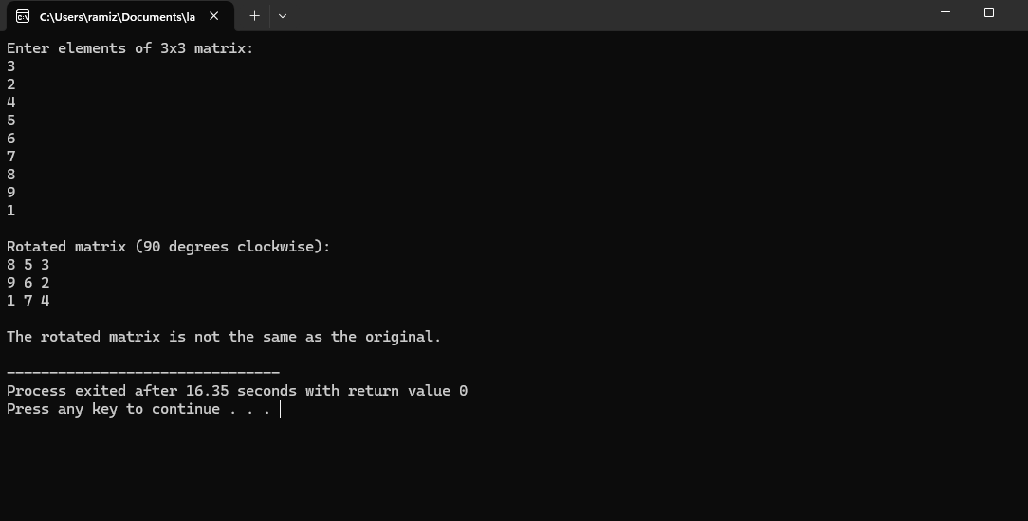

Task 10
#include <stdio.h>

int factorial(int n) {
int i, fact = 1;
for (i = 1; i <= n; i++)
fact *= i;
return fact;
}

int main() {
int n, i, j;
printf("Enter number of rows: ");
scanf("%d", &n);

for (i = 0; i < n; i++) {
for (j = 0; j < n - i - 1; j++)
printf(" ");
for (j = 0; j <= i; j++)
printf("%d ", factorial(i) / (factorial(j) * factorial(i - j)));
printf("\n");
}

return 0;
}

